In the
Win a Bike
Eco-Champions Challenge

In partnership with

Supporting the Central Area Council
and The Great British Spring Clean

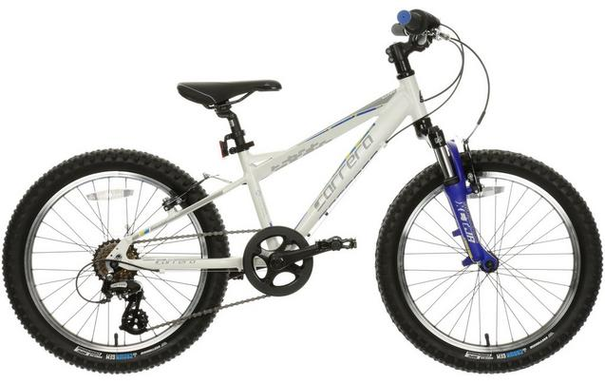
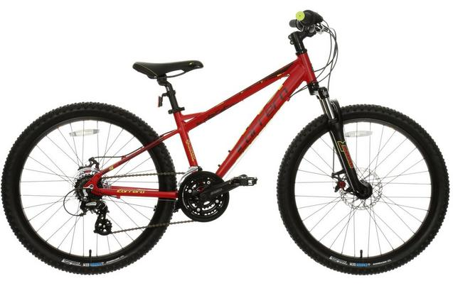

Your chance to win a bike, as well as a host of other goodies for the top three dedicated young Eco-Champions

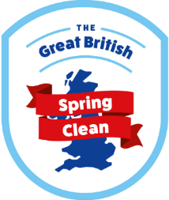

Entry Steps
The first place prize will be an amazing Halfords bike worth £275. The bike will be a ‘Carrera Blast’ or a ‘Carrera Luna’ with either 20” or 24” wheels. Great 2nd and 3rd place prizes will also be awarded.
To be part of the chance to win the fantastic prize please follow the following steps:

- Pick up a submission sheet from:
- Halfords (Harborough Hills Branch)
- Kendray Business Centre, S70 3NA
- Vera Mawby Centre, Worsbrough Common S70 4ND
- Barnsley Library, The Lightbox
Or download it from www.twiggsuk.co.uk
- Carry out tasks that support the great British Spring Clean in your own neighbourhood, park or local area.
- Provide evidence of your activities on the submission sheet (show off as much as you can about the results of your work) and then drop off at one of the four above named locations between March 30th and Saturday 4th April.
- Activities are to be carried out throughout the month of March
- Most importantly: Be Safe and Have Fun! Further details including Health and Safety guidance can be found at http://www.keepbritaintidy.org/
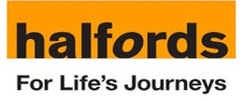

- As this is a singular 1st prize, the name at the top of the sheet is the entrant who will be presented with the prizes.
Rules and Guidelines

- As many people can take part, the more the merrier. This will go favourably towards the overall judging scoring and awarding.

- The leading Participant must be between the ages of 5 and 12 years old.

- Any activities carried out will be at the sole responsibility of the legal parent/ guardian of the child. Parent/ guardian must be over the age of 18.

- Please ensure all permissions of land owners etc. have been obtained beforehand.

- Points and the eventual winner will be awarded on:
- Amount of litter waste removed
- Recycling practices – including ‘green waste’ to make wildlife habitats
- The number of people involved
- Photographic evidence before and after – physical improvement of the area
- Overall Environmental Impact
- Volunteer hours accrued

- This is to be a standalone project and not working in partnership with other organisations or community groups carrying out their clean-up activities.

- Children must be supervised at all times.

- Please do not put yourself in any dangerous situations that you are unable to control.

- Evidence including photos be can attached or sent via email to community@twiggsuk.co.uk... please ensure they have the correct information (name of participant, name and contact phone number of responsible adult, and post code) so we can match them accordingly.

- You must be available on the 11th April for the awarding of the prizes. Further details will be provided upon submission.
Entrants Name: ____________________ Age: _______
Submission Sheet
Parent/Guardian Name and tel. number: __________________________
Postcode: ___________
Description of the tasks that took place and what they have achieved. Also include as much information as to who, what, where and why:

Additional/ Supporting Evidence (photo evidence can also be emailed to community@twiggsuk.co.uk)

No. of Sacks of litter removed:
Hours of work volunteered:

